H.T No
Regulations:
A15


Sreenidhi Institute of Science and Technology
(An Autonomous Institution)
Code No: 5CC16 Date: 26-Nov-2018 (FN)

B.Tech III-Year I-Semester End External Examination, November - 2018 (Regular)
Linear and Digital IC Apllications (EEE and ECM)

Time: 3 Hours Max.Marks:75

Note: a) No additional answer sheets will be provided.
b) All sub-parts of a question must be answered at one place only, otherwise it will not be valued.
c) Missing data can be assumed suitably.

Part - A Max.Marks:25

Answer all QUESTIONS.

1. | Compare inverting and non-inverting OP-AMP. | [3M]
2. | Define Hysteresis width and duty cycle. | [3M]
3. | Design a first order Active low pass filter with cutoff frequency of 10KHz with pass band gain of 2 using OP-AMP. | [3M]
4. | What are the characteristic parameters of D/A converter? | [3M]
5. | Explain the working of TTL NAND gate with neat diagram. | [3M]
6. | Design multiplexer for the given function minterms 1, 2, 3, 5, 7 using 4X1 Multiplexer. | [2M]
7. | Define negative peak detector. | [2M]
8. | What is the difference between UTP and LTP? | [2M]
9. | What is meant by race around condition? | [2M]
10. | Realize the full adder circuit using 4x1 multiplexers. | [2M]
Part – B Max.Marks:50
ANSWER ANY FIVE QUESTIONS. EACH QUESTION CARRIES 10 MARKS.

11. | a) | Explain the internal block diagram of OP-AMP. | [5M]
 | b) | Write about AC and DC characteristics of OP-AMP. | [5M]
12. | a) | Describe the functioning of an Instrumentation amplifier with a circuit diagram. | [5M]
 | b) | Explain V to I and I to V converters using OP-AMP. | [5M]
13. | a) | Design an active network for generation of square wave. Describe its functioning. | [5M]
 | b) | Draw and explain Free running multivibrator using 555 timer. | [5M]
14. | a) | Derive the expression for frequency of oscillations of Wein bridge oscillator. | [5M]
 | b) | Describe with neat diagram functioning of dual slope ADC. | [5M]
15. | a) | Compare TTL Logic families. | [5M]
 | b) | Compare open collector configuration with totem pole configuration. | [5M]
16. | a) | Draw and explain priority encoder. | [5M]
 | b) | Explain decade counter with neat diagram. | [5M]
17. | a) | Determine V_{A} and V_{B} when, V₁ = 1V and V₂ = 2V  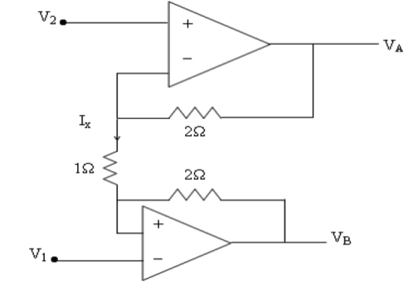 | [4M]
 | b) | Write short notes on S/H circuit. | [3M]
 | c) | What is the significance of Band Pass Filter? Explain. | [3M]
18. | a) | Discuss the operation of parallel comparator type ADC with the help of a neat diagram. | [4M]
 | b) | With respect to logic families, explain fan-out propagation delay and FOM. | [3M]
 | c) | How race around condition is eliminated by master slave flip flop? Explain. | [3M]
-- 00 -- 00 –

